RSA

**TEST CASES – MS1**

# SAMPLE TESTS

|  |  |
| --- | --- |
| **Test cases** | **Output file** |
| AddTestCases.txt | AddTestCases_Output.txt: Test **ADD** function |
| MultiplyTestCases.txt | MultiplyTestCases_Output.txt: Test **MULTIPLY** function |
| SubtractTestCases.txt | SubtractTestCases_Output.txt: Test **SUBTRACT** fuction |

## Cases Output Description

**You shall output these for each case in milestone 1:**

* A text file **SIMILAR EXACTLY** to AddTestCases_Output.txt
* A text file **SIMILAR EXACTLY** to MultiplyTestCases_Output.txt
* A text file **SIMILAR EXACTLY** to SubtractTestCases_Output.txt

**The text file format:**

* The output for each case in a SEPARATE line followed by an EMPTY line.

**Do the following steps to compare your output file with the expected results (YOU MUST FOLLOW AS THESE STEPS WILL BE DONE IN THE DELIVERY TO VALIDATE YOUR OUTPUT):**

1. Download a comparer software named “Beyond Compare” from [**here**](https://www.scootersoftware.com/download.php)and install it.
   * While installing select “Include in Explorer context menu” as follows:

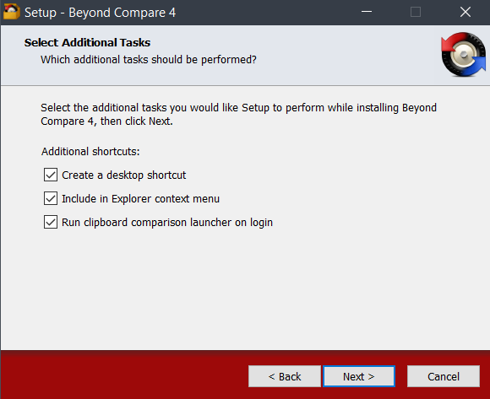

1. Use it to compare your output with **AddTestCases.txt:**
   * **Select the two text files (Your output file and the expected one)**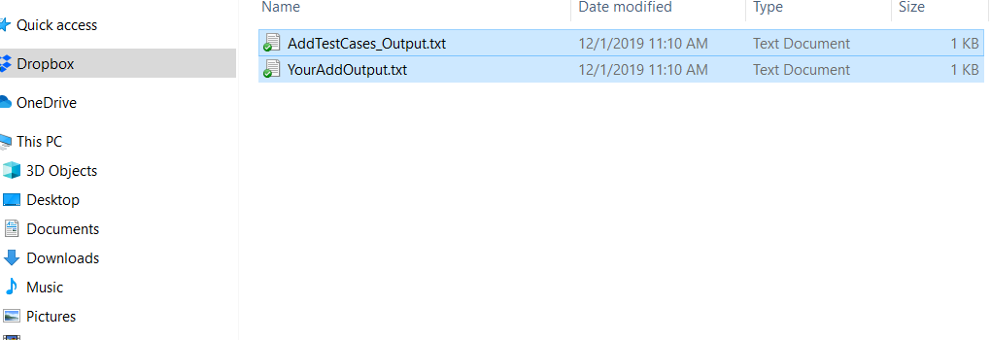
   * **Right click after your selection and select “Compare”**

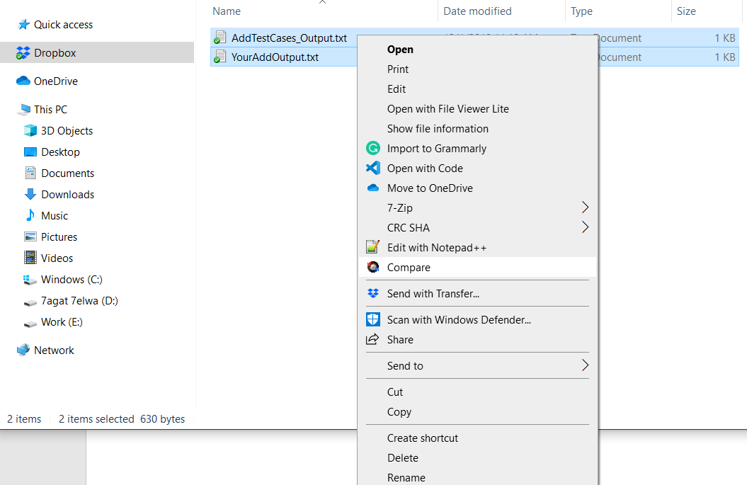

* + **You will see the beyond compare open the two files beside each other:**  
    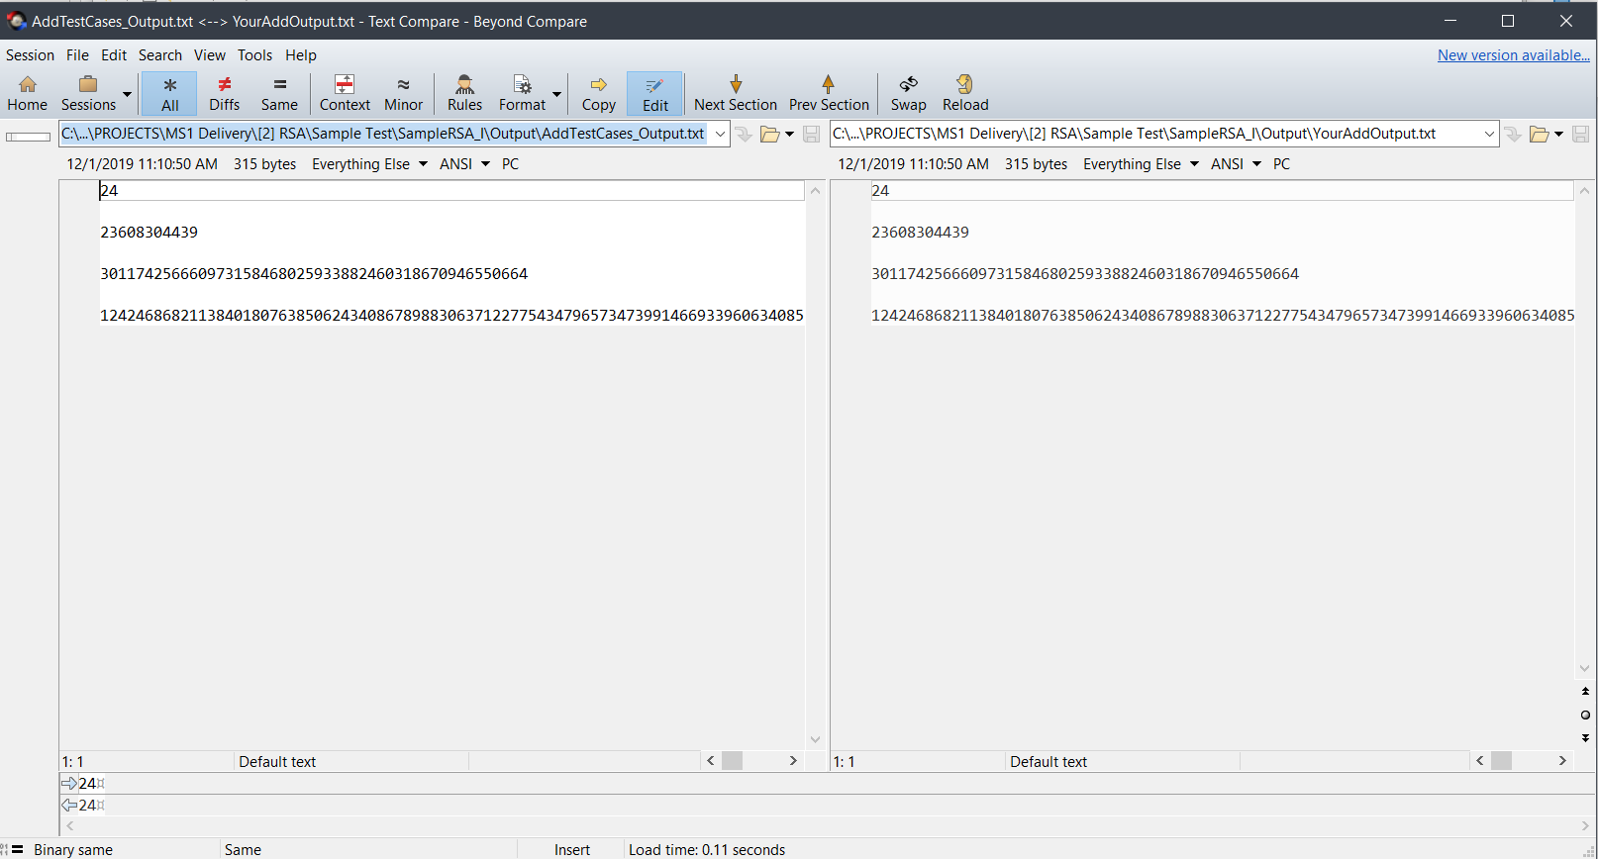
  + Click on the “Diffs” in the above toolbar.
    1. [**REQUIRED**] If you output the **correct results** in **correct format (i.e. your output file is IDENTICAL to the expected file)**, you will see nothing in it as the following:  
       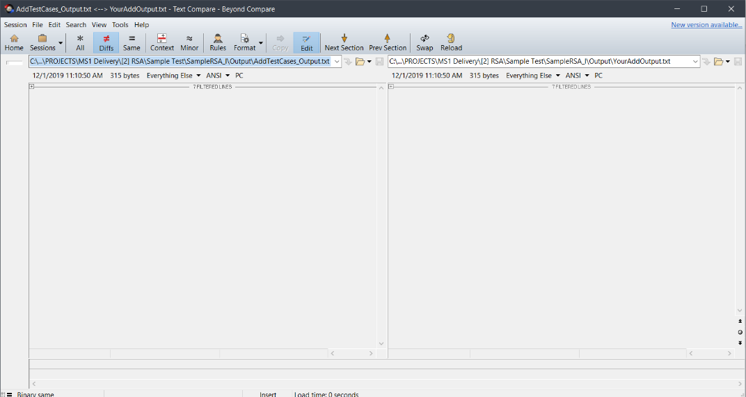
    2. [**NOT REQUIRED**] Otherwise if one of the results is wrong or there are no empty spaces between each test case output you will see this: 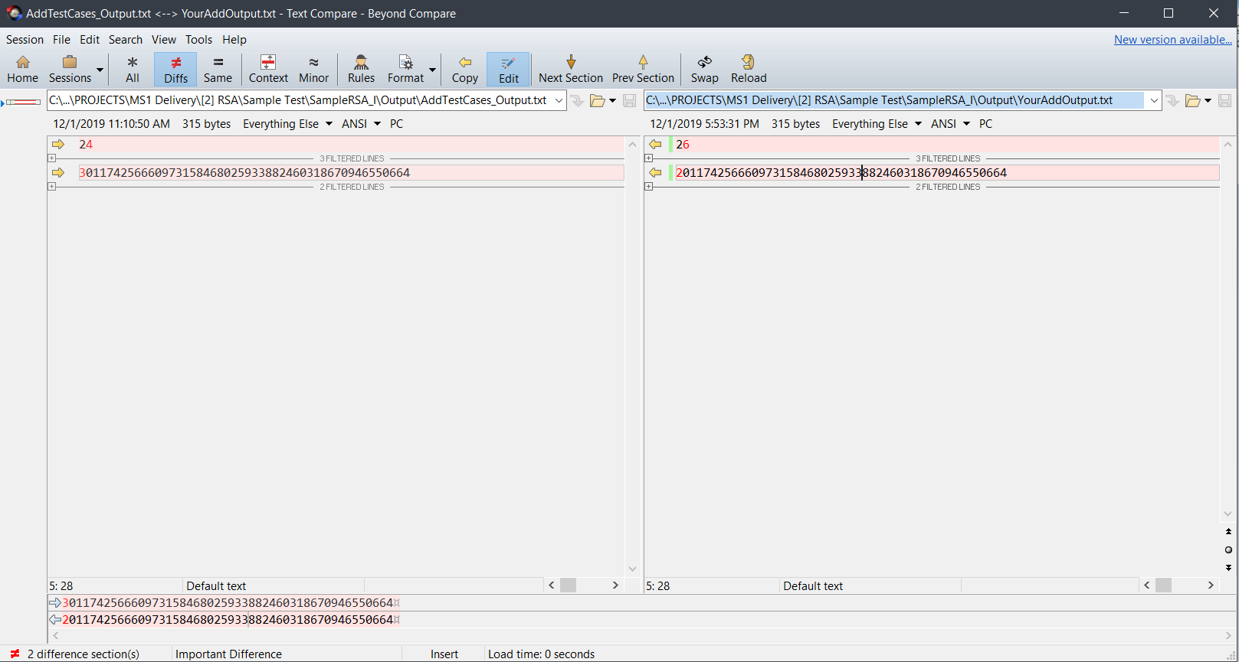

This means that my output is wrong as the expected output in a case is 24 while my output is 26 which is indicator for **WRONG OUTPUT**.

KINDLY FOLLOWS THESES STEPS CAREFULLY FOR VALIDATION AS THIS IS THE SAME WAY WILL BE USED IN MS1 & MS2 DELIVERY